Task 1

Due to machine setup and browser …it took lot of time for me to write a program…

Unable to run this program in broswer due to machine issue.

Task

● Please try to configure Chrome Browser or firefox browser and navigate to

https://datatables.net/

● Select 50 entries per page using the drop down. Now you will get 2 pages.

● Get the list of employee name in the page 1 and page 2, whose age is greater than or equal

to 50 and salary is greater than or equal to $200,000

● Print the name in the console.

Program

**package** AssessmentExam;

**import** java.util.List;

**import** java.util.concurrent.TimeUnit;

**import** org.openqa.selenium.By;

**import** org.openqa.selenium.WebDriver;

**import** org.openqa.selenium.WebElement;

**import** org.openqa.selenium.chrome.ChromeDriver;

**import** org.openqa.selenium.support.ui.Select;

**public** **class** DataTablesTest {

**public** **static** **void** main(String[] args) {

//Open browser

System.*setProperty*("webdriver.chrome.driver", "./chromedriver.exe");

WebDriver driver=**new** ChromeDriver();

//Open Website

driver.get("https://datatables.net/");

driver.manage().window().maximize();

driver.manage().timeouts().implicitlyWait(30, TimeUnit.***SECONDS***);

//Selecting dropdown value

WebElement dropDownBox=driver.findElement(By.*name*("example_length"));

Select select=**new** Select(dropDownBox);

select.selectByValue("50");

//list of values from table

List<WebElement> tableRows=(List<WebElement>) driver.findElement(By.*xpath*("//table[@id='example']/tbody/tr"));

//Finding table size

**int** tableSize=tableRows.size();

System.***out***.println(tableSize);

//Running loop to find age of employees and salary

**for**(**int** i=1;i<=tableSize;i++)

{

WebElement namesList=driver.findElement(By.*xpath*("//table[@id='example']/tbody/tr[1]/td["+i+"]"));

namesList.click();

String employeeNames=namesList.getText();

WebElement ageList=driver.findElement(By.*xpath*("//table[@id='example']/tbody/tr[1]/td["+(i+3)+""));

String ageOfEmploye=ageList.getText();

**int** ageOfEmployee=Integer.*parseInt*(ageOfEmployee);

**if**(ageOfEmployee>50) {

System.***out***.println(employeeNames);

}

}

}

}

Screenshot

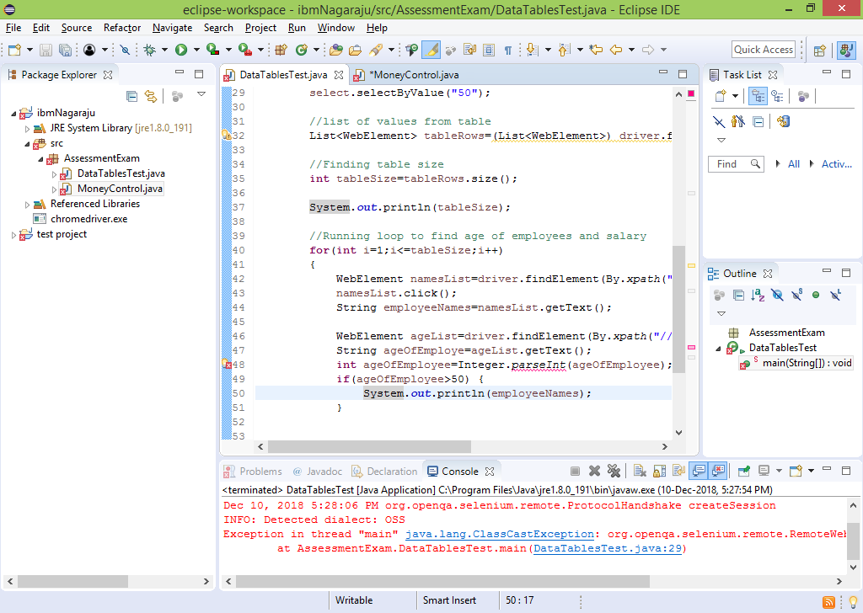

Task 2

Task

● Please launch https://www.moneycontrol.com/

● Click on Stocks links (Highlighted near Signup)

Program

**package** AssessmentExam;

**import** java.util.concurrent.TimeUnit;

**import** org.openqa.selenium.WebDriver;

**import** org.openqa.selenium.chrome.ChromeDriver;

**public** **class** MoneyControl {

**public** **static** **void** main(String[] args) {

//Open browser

System.*setProperty*("webdriver.chrome.driver", "./chromedriver.exe");

WebDriver driver=**new** ChromeDriver();

//OPEN website

driver.get("https://www.moneycontrol.com/");

driver.manage().window().maximize();

driver.manage().timeouts().implicitlyWait(30, TimeUnit.***SECONDS***);

//Click on stocks in website

WebElement stocks=driver.findElement("By.xpath("//link[@className='link1'])");

}

}

Screen shot

